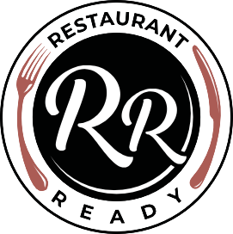

TASTING MENU SAMPLE 1.

FARM “READY” SALAD | AVOCADO PUREE | GOATS CURD | CRISPY ONIONS | TOMATO DRESSING
(GOOD FOR – HEALTHY FATS, VITAMINS, PROTEIN, FIBER, POTASSIUM, LOW CARBS)

* * *

WAGYU BEEF TARTARE | WASABI & LIME | GOATS CURD | CANDIED HAZELNUT | CAPERS | HAZELNUT DRESSING
GOOD FOR- FIBRE, VITAMINS, HEALTHY FATS, IRON, LOW CARBS)

* * *

GRESSINGHAM DUCK BREAST | ROAST PEACH | GLAZED BOK CHOI | UME SHISO & SOY DRESSING
(GOOD FOR – PROTEIN, IRON, VITAMINS, MINERALS, LOW CARBS)

* * *

TORCHED MACKERAL | SCALLOP & GOOSEBERRY SAUCE | TURNIP & RADISH
(GOOD FOR – PROTEIN, POTASSIUM, VITAMIN, IRON, FIBER, LOW CARB)

* * *

CAULIFLOWER & CELERY RISOTTO | PICKLED CELERY | ROAST CAULIFLOWER | GRAPE & RAISEN DRESSING
(GOOD FOR – VITAMINS, POTASSIUM, MINERALS, IRON, FIBER, HIGH CARBS)

* * *

EGG CUSTARD TART | NUTMEG ICE CREAM
(GOOD FOR – PROTEIN, FIBER, LOW CARBS & REDUCED FAT)

* * *

THE JAFFA CAKE | SALTED CHOCOLATE MOUSSE | ORANGE ICE CREAM | POPPY SEED MADELINES
(GOOD FOR – IRON, FIBER, REDUCED FAT, VITAMIN C, CALCIUM, IRON)

